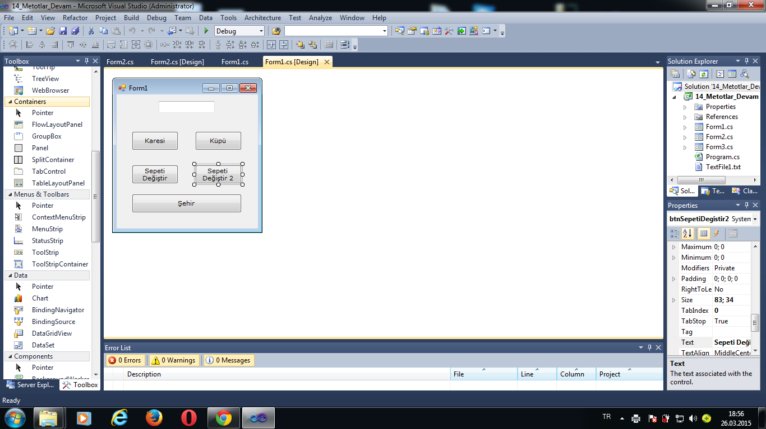

using System;
using System.Collections.Generic;
using System.ComponentModel;
using System.Data;
using System.Drawing;
using System.Linq;
using System.Text;
using System.Windows.Forms;

namespace _14_Metotlar_Devam
{
public partial class Form1 : Form
{
public Form1()
{
InitializeComponent();
}

private void Karesi(int sayi)
{
sayi *= sayi;
}

private double Kupu(double sayi)
{
sayi = sayi * sayi * sayi;

return sayi;
}

private void btnKaresi_Click(object sender, EventArgs e)
{
int sayim = int.Parse(txtSayi1.Text);

Karesi(sayim);

this.Text = sayim.ToString();
}

private void btnKupu_Click(object sender, EventArgs e)
{
double kupum = double.Parse(txtSayi1.Text);

this.Text=Kupu(kupum).ToString();
this.Text +=" - " + kupum.ToString();

}

private void SepetiDegistir(string[] urunler)
{
urunler[1] = "Süt";
}

private void btnSepetiDegistir_Click(object sender, EventArgs e)
{
string[] sepetim = {"Ekmek","Peynir","Yoğurt" };

SepetiDegistir(sepetim);

#region mustafanın sorusu
//string deger = string.Empty;
//for (int i = 0; i < sepetim.Length; i++)
//{
// deger += sepetim[i];
//}
#endregion

this.Text = sepetim[1];
}

private void btnSepetiDegistir2_Click(object sender, EventArgs e)
{
string[] mustafaninSepeti = { "süt","vişne","çilek","kola"};
string[] zeynebinSepeti = {"Ruj","Rimel","Allık","Oje" };

mustafaninSepeti = zeynebinSepeti;

mustafaninSepeti[1] = "fanta";

this.Text = mustafaninSepeti[1] + " " + zeynebinSepeti[1];

int sayi1 = 5;
int sayi2 = 7;

sayi1 = sayi2;

sayi1 = 6;

//sayi1 ve sayi2
//6 ve 7
}

private void btnSehir_Click(object sender, EventArgs e)
{
string sehir = "Ankara";

string city = "İstanbul";

sehir = city;

sehir += " City";

this.Text = city;
}

}
}

